**MONGODB**

* Document database
* NoSQL database
* A record in mongodb is a document,which is a datastrucre with field and value pair

|  |  |
| --- | --- |
| Mongo db | Sql |
| Database | Database |
| collection | Table |
| Document | Rows |
| fields | Columns |
|  |  |

**Steps:**

1. Open “cmd”

Type mongo

Output: mongo is not recognized

1. Open the folder where mongodb is installed (c drive) 🡪program file🡪mongodb🡪server🡪7🡪bin🡪 copy that folder path (like : C:\Program Files\MongoDB\Server\7.0\bin)
2. Add that path to environment variable

Search “env” -🡪select edit system env variable.-->advanced🡪environment variables🡪path🡪edit🡪new🡪paste that copied path.-->ok-🡪ok—ok

Then we can run mongodb command

1. Close the previous command prompt and Open new one.
2. Type mongo---🡪success.

If any error happens u need to download mongoshell from website.

And set path as above

1. New cmd🡪mongod –version

Success

1. Mongosh

Success

Then connection between client and server is established.

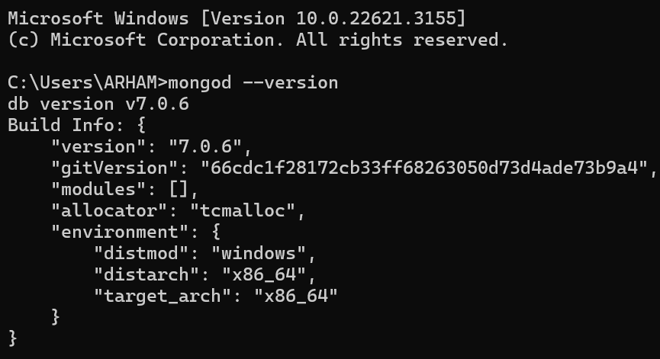

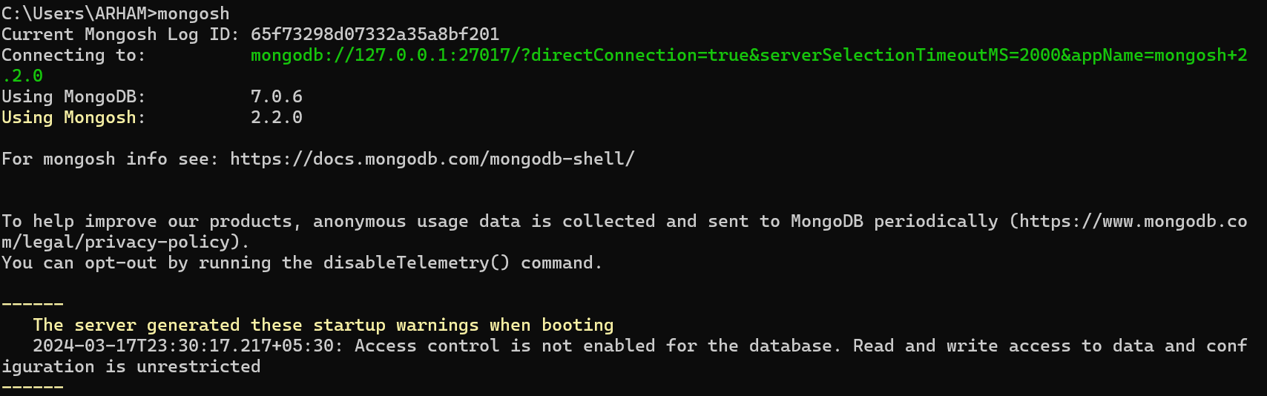

1. Show dbs

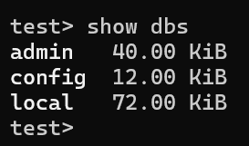

1. Create own db

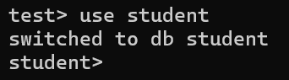

Check where created “student “ db in list

Its not there unless u create a collection

db.createCollection("dbms")

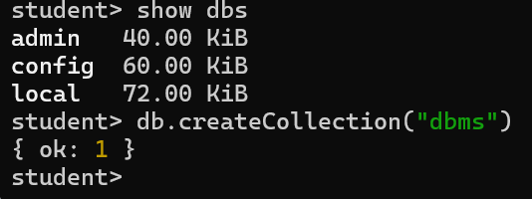

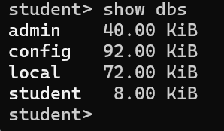

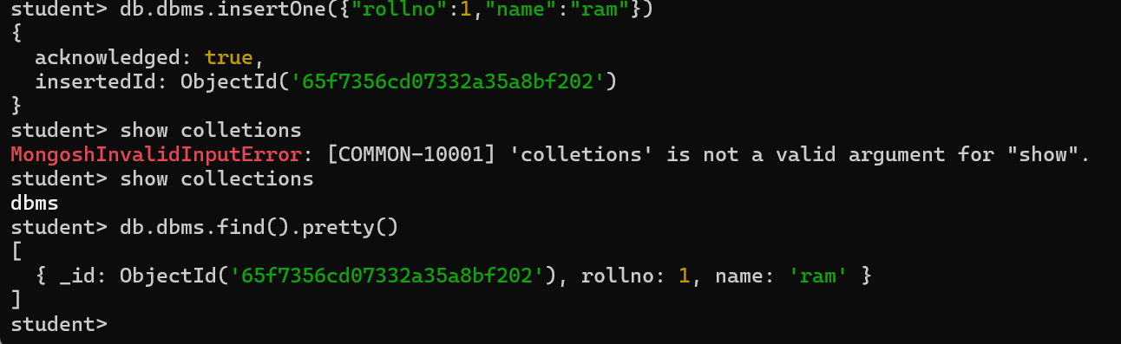

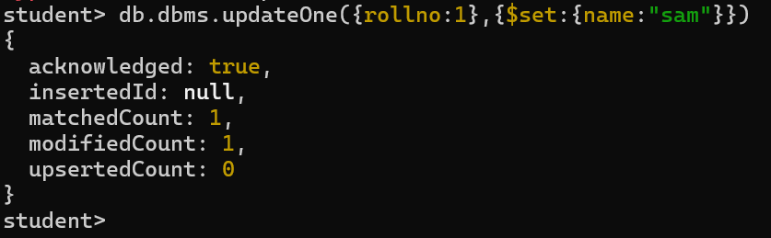

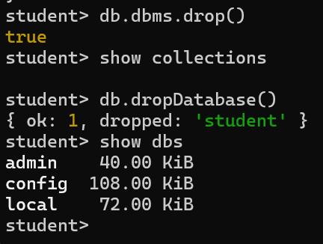

CREATE AND DROP DATABASE

